

Asha MFI User Guide

v1.0.0

**Preliminary Info:**

* This guide is a reference for Asha MFI software and is the only document for that purpose.
* It gives an introduction to the modules and services that Asha MFI uses.
* We recommend you follow along with this guide when first using Asha MFI. It is designed to give you a comprehensive idea on how the software works in the shortest amount of time.
* You will need annexes to perform a complete implementation and configuration.
* To contact us, please send us an email to [info@prabhumanagement.com](mailto:info@prabhumanagement.com).

Table of Contents

1. Get Started 4

1.1 Launch Asha MFI 4

2. Initial Steps 5

2.1 Get familiar with the Interface 5

2.1.1 1. Fiscal Year and Current Date 5

2.1.2 2. Change Password and Logout 5

2.1.2.1 Change Password 6

2.1.2.2 Logout 6

2.1.3 3. Fast Menu Access 6

2.1.4 4. Operations Dashboard 6

2.2 Terms/Images/icons Used in this User Manual 7

2.3 Where to go from here? 7

3. Center Details 8

4. Member 8

5. Transaction 8

6. Reports 8

# Get Started

## 1.1 Launch Asha MFI

* Open any of your favorite Internet browser (E.g. Google Chrome, Mozilla Firefox, etc.). We prefer you to use Google Chrome.



* On the Address bar, type in the following address to open Asha MFI application. Since we have developed Asha MFI software as SAAS, you can access the software from anywhere with any medium provided Internet access is present.



* You will see the following login panel on your browser.

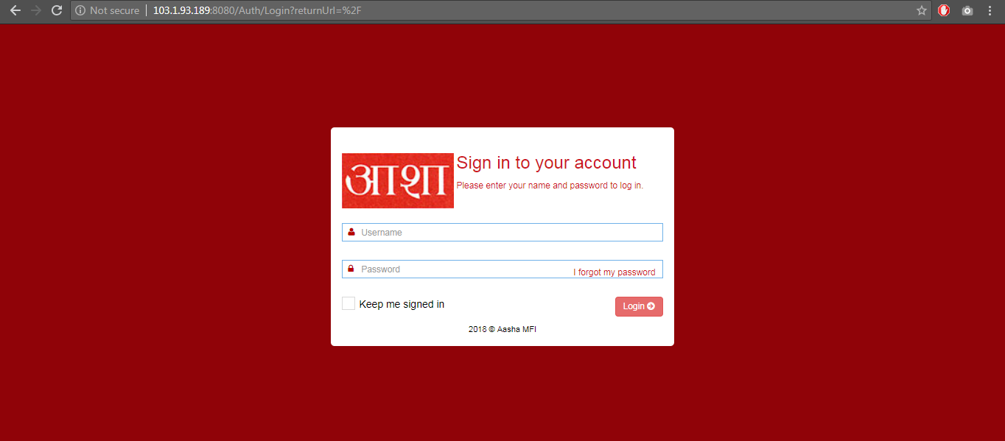

* Enter your username in the ‘Username’ field and password in the ‘Password’ field, and click on ‘Login’ button.

The System is now ready to go.

# Initial Steps

## Get familiar with the Interface

You can always go to the ‘Dashboard’ by clicking on the Asha logo in the left top corner.

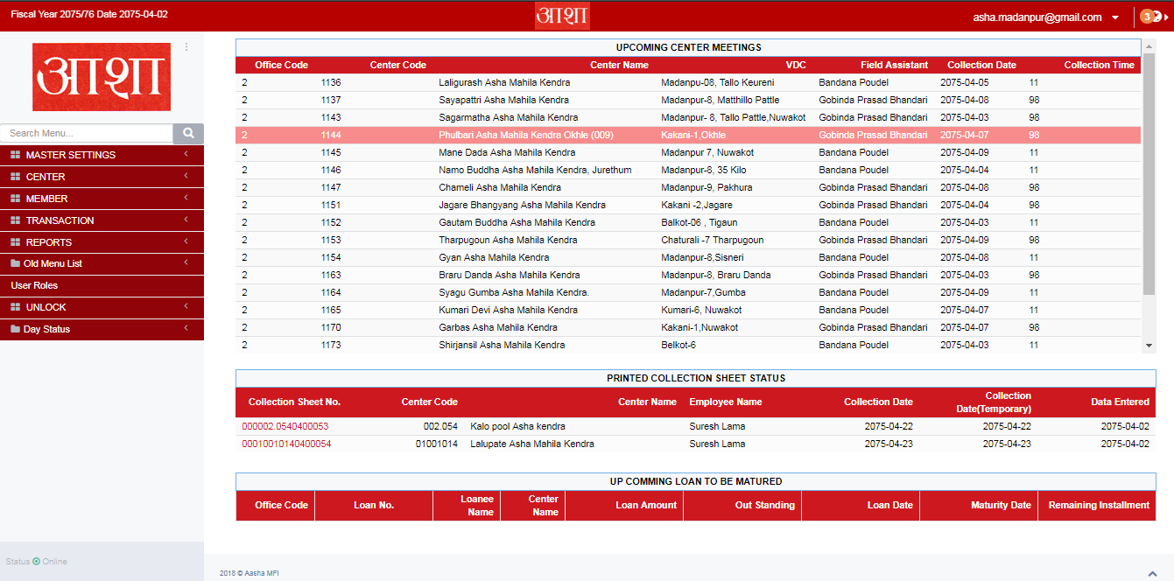

### 1. Fiscal Year and Current Date

This menu shows the Current Fiscal Year as well as the date the Branch currently is in. If you hover the mouse over the Current Date, it will display the same date in AD format as well as the Day as well.



### 2. Change Password and Logout

This is the panel which displays your Login information. When clicked on the Down Caret symbol, the dropdown menu further shows ‘Change Password’ and ‘Logout’ option.

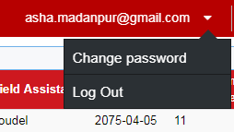

#### Change Password

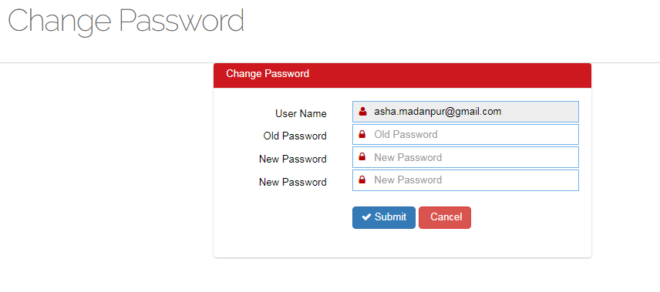

Your Username will be already displayed on the Username section. Please enter the current password in the Old Password. Then Enter and Re-enter New Password in the New Password Section. Press Submit to Change your Password.

#### Logout

Logout will destroy all the login sessions and send you back to the ‘Login’ page. Once you logout, you need to re-login to access the system.

### 3. Fast Menu Access

You can access all the pages and modules directly from the link of the left menu. The menu bar is collapsible if there are further sub-menus and can be collapsed by clicking on the arrow icon at the right side.

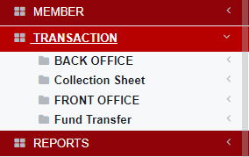

### 4. Operations Dashboard

The Dashboard’s primary purpose is to give employees a straightforward overview at a glance about Upcoming Center Meetings, Printed Collection Sheet Status and Upcoming Loan to be matured.

## Terms/Images/icons Used in this User Manual

Throughout this User Manual, you will see some icons highlighted more frequently than others. This icons have their own purposes and will be uniform over the manual.

|  |  |
| --- | --- |
|  | When clicked on this icon, it will redirect you to a new page where you can add respective NEW records. |
|  | This icon is used to display the FILTERS available for that page. This can be used to view overall data or check only particular data, e.g., Date-wise, Center-wise, Branch-wise, etc. |
|  | This is PRINT icon. If you want to print any reports or the page this icon can be clicked to bring the PRINT dialog box. |
|  | This is EDIT icon. If you want to edit any row/record, then you should click on this icon to make changes. |
|  | This is VIEW icon. If you want to view the more details for any row, you should click on this icon to view in more details about the record |
|  | This is LINK icon. If there are further reports to be viewed, you can click on this icon. This icon is commonly found in the ‘**Center Entry**’ page. On click, this link will show the Center Evaluation List. |
|  | You will see this used in most of the pages where records are need to be shown. This options allows you show the number of records per page. Available options are 10, 25, 50 and 100 rows. |
|  | You can search for the records directly from here. Start typing the text and it will automatically detect the records for you and show it, thus in the process hiding all others. To view all records again, please clear the text on the Search textbox. |

## Where to go from here?

Now that we are familiar with how the website looks and what to look out for, we can start using the software. Please proceed to next section on further How-to.

# Center Details

# Member

# Transaction

# Reports